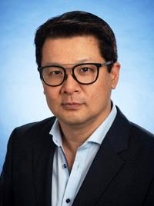

Dr. Alexander Sun MD, FRCPC
Associate Professor
Department of Radiation Oncology, University of Toronto
Toronto, ON

Dr. Alex Sun is a radiation oncologist at Princess Margaret Cancer Centre with a substantial track record of clinical research in thoracic radiation oncology. He has held national and international leadership positions is several research, policy and educational organizations, including academic clinical trials groups. His research interests include the development of clinical trials to improve outcomes in lung cancer patients through the integration of Positron Emission Tomography (PET) imaging in the management of lung cancer and to define the role of prophylactic cranial irradiation (PCI). More recently, his research interests have also incorporated the combining of immunotherapy (I/O) with radiation.
Dr. Sun is currently the Addie MacNaughton Chair in Thoracic Radiation Oncology at Princess Margaret Cancer Centre/University of Toronto and is an Associate Professor, in the Department of Radiation Oncology, University of Toronto. He is also the NRG Oncology Principal Investigator for Princess Margaret Cancer Centre and is a member of the NRG Oncology Lung Cancer Steering Committee as well as the Co-Chair of the CCTG Lung Disease Site Committee.

